Alarm Clock

Version 1.0

Revision History

|  |  |  |  |
| --- | --- | --- | --- |
| **Date** | **Version** | **Description** | **Author** |
| 28/11/2016 | 1.0 | Initial Creation | Benedikt Bosshammer |

Table of Contents

1. Introduction 4

1.1 Purpose 4

1.2 Scope 4

1.3 Definitions, Acronyms, and Abbreviations 4

1.4 References 4

1.5 Overview 4

2. Architectural Representation 4

3. Architectural Goals and Constraints 4

4. Use-Case View 4

5. Logical View 4

5.1 Overview 5

5.2 Architecturally Significant Design Packages 5

6. Process View 5

7. Deployment View 5

8. Implementation View 5

9. Data View 5

10. Size and Performance 5

11. Quality 5

# Introduction

## Purpose

This document provides a comprehensive architectural overview of the system, using a number of different architectural views to depict different aspects of the system. It is intended to capture and convey the significant architectural decisions which have been made on the system.

## Scope

The scope of this SAD is to show the architecture of the Chezz application. Affected are the class structure, the use cases and the data representation.

## Definitions, Acronyms, and Abbreviations

|  |  |
| --- | --- |
| SAD | Software Architecture Document |
| tbd | to be determined |

## References

## Overview

This document describes the software architecture to ensure that everybody understands it and new devlopers can be let into the project easily.

It describes how the application is structured, why it is structured like it is and what we do to ensure that our code meets a certain quality standard.

# Architectural Representation

This project will use the MVC architecture, which Swift utilizes by default.

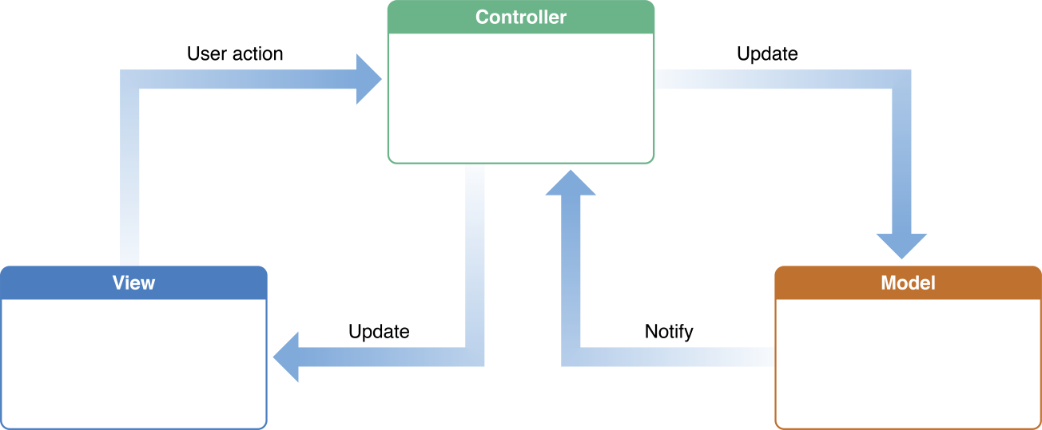

<https://developer.apple.com/library/mac/documentation/General/Conceptual/DevPedia-CocoaCore/MVC.html>

# Architectural Goals and Constraints

The main goal of the MVC architecture is to separate the view from the logic. Therefore the view knows nothing on its own, but gets all information from the logical part. Swift automatically creates projects based on the MVC pattern.

# Use-Case View

n/a

# Logical View

TODO René

## Overview

## Architecturally Significant Design Packages

# Process View

(n/a)

# Deployment View

The deployment view for this application is rather simple. To run the application the user needs and iPhone or iPad with a current iOS version. He then will be able to download the application via the iOS AppStore.

For development it is also possible to install the application directly from a Mac with XCode or AppCode.

There are no hardware requirements, as all iOS devices with a current version are capable of running the application.

# Implementation View

(n/a)

# Data View

TODO René

The shown database diagram shows the current state. There will be more entities throughout the development of the application.

Swift uses Core Data for data persistence, which is based on sqLite (good for mobile apps).

# Size and Performance

(n/a)

# Quality

For nowadays standards the quality of our application is important to find stoutness in a great audience. Current standards are based on a flat ui design as well as clear and structured interfaces. The app should be used intuitively.

We try to build an extensible structure, so there is always the possibility for us to create new game modes or add other features. Due to Swift, the application will be available for all modern iOS devices. The migration to OSX in the end should be simple.